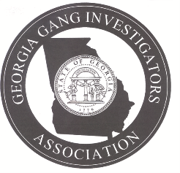 Georgia Gang Investigators Association
GGIA Human Trafficking Gang Investigator Certification Course
The Board of Directors for the Georgia Gang Investigators Association (GGIA) are excited to announce that GGIA will be offering our Human Trafficking Gang Investigators Certification Course on Monday, March 7, 2022, at the Georgia Bureau of Investigation’s Division of Forensic Sciences (DOFS) Conference/Training Room, 3121 Panthersville Road, Decatur, GA 30034
Personnel applying to obtain a GGIA Human Trafficking Gang Investigator Certification must meet the following criteria:
- Be a current member in good standing of the Georgia Gang Investigators Association
- Pay a tuition cost of $40.00 (Add $5.00 processing fee for credit card payment)
- Attend the entire 8-hour GGIA Human Trafficking Gang Investigator Certification Course
- Successfully pass the Human Trafficking Gang Investigator Certification test of 40 questions with minimum score of 70%
This certification class is open for all GGIA members who have successfully completed the Basic Gang Investigator's Certification Course or who are currently assigned as a special victim’s unit investigator or prosecutor.
Note: Those GGIA members who have successfully completed the Intermediate Gang Investigators Certification Course will be given priority during the registration process.
There will be required reading material provided to attendees 14 days prior to the class. These reading assignments will contain material that will be part of the final exam.

Register at: https://ggia.net/training/

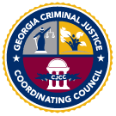This training is sponsored in part by the Criminal Justice Coordinating Council

